

**INFORMATICS INSTITUTE OF TECHNOLOGY**

**3D Interactive Media Development**

**5MMCS007C.1**

Module leader: Mr. Jeff Ferguson

Coursework 1: Group Report

|  |  |  |  |
| --- | --- | --- | --- |
| **Name** | **UoW No** | **IIT No** | **Group** |
| H. M. V. T. L. Somarathne (Leader) | w1956337 | 20221495 | IM1 |
| D.C.D.W Gunawardhana | w1985637 | 20221891 | IM1 |
| S.A.B. Nanayakkara | w1985630 | 20221869 | IM1 |
| Sathnidu Jayadheera | w1954087 | 20220889 | IM1 |

Contents

**Concept And Design** 3

**Research and References** 3

**References** 4

**Problem and Project Concept** 4

**Basic Design** 5

**3DUI theory and concepts used (Based off lectures or book)** 9

**Design Diagram** 10

**Storyboard** 10

Storyboard Flow 11

**Flow Chart** 12

**Use Case Diagram** 13

**Project Management Methodology** 14

**Commercial Analysis** 14

**Navigation Framework** 15

**Interactivity** 15

**Animations** 16

**Shading, Lighting, and texturing** 16

**Shading:** 17

**Texturing:** 17

**Special Effects** 18

**Discuss UI Efficacy** 18

**Group Contributions and Videos** 18

# **Concept And Design**

## **Research and References**

Procedural learning, often known as skill learning, is the practice and repetition of knowledge or abilities (Anderson, 2000). Procedural learning, which involves the learning of information or concepts, can be compared with it. Procedural learning is especially pertinent to this endeavor since it is critical in the development of motor abilities such as driving, handling weapons, and conducting military maneuvers.

The basis for competence is procedural learning. It enables humans to execute complex activities automatically by fostering skill mastery. From battlefield expertise to everyday tasks, procedural learning shapes our ability to interact with the world.

To encourage successful learning and knowledge keeping, the simulation will also incorporate educational psychology principles. Meaningful learning happens when new information is linked to existing knowledge systems, according to Ausubel (2000). To help with learning and memory, the simulation will include contextual hints, interactive graphics, and multimedia features. Furthermore, the simulation will allow for active learning by allowing users to apply their knowledge through hands-on engagements with numerous aspects such as driving vehicles, firing weapons, and interacting with soldiers.

## **References**

1. Anderson, J. R. (2000). Learning and memory: An integrated approach. John Wiley & Sons.
2. Ausubel, D. P. (2000). The acquisition and retention of knowledge: Cognitive aspects of information processing. Kluwer Academic Publishers.
3. FIRST PERSON MOVEMENT in Unity - FPS Controller (Brackeys, 2019, October 28). Retrieved from <https://www.youtube.com/watch?v=_QajrabyTJc>
4. LaViola Jr., J. J., Kruijff, E., McMahan, R. P., Bowman, D., & Poupyrev, I. P. (2017). 3D User Interfaces: Theory and Practice (2nd ed.). Addison-Wesley Professional.
5. Unity Technologies (2023). Unity User Manual. Retrieved from https://docs.unity3d.com/Manual/index.html.

## **Problem and Project Concept**

In today's world, a military base is one that is equipped with the most modern weapons and technology. A common man can never see some of the weapons there. A military base is not open to the public due to various reasons such as due to the security reasons of the military base and if the people visit them frequently, it is not possible to maintain their activities properly. It is essential to get permission from a higher official to get a mandate to go there. As a solution to that problem, we will show our 3D military base simulation concept.

Our 3D interactive military base simulation is designed to provide users with an immersive and engaging experience that allows them to visit various areas of a military base, interact with soldiers and vehicles and learn about military activities. The simulation will be created with Unity and Legos, and it will include a range of interactive components inspired by concepts.

## **Basic Design**

With our immersive 3D interactive simulation, you can feel as though you are in the center of a busy military base. Through this immersive experience, you will be taken to a world of painstakingly constructed military buildings, vehicles, and people. You will be able to explore every inch of the base and interact directly with its residents. Enjoy the excitement of driving a variety of vehicles, participating in firing range training, and interacting with soldiers by shaking hands, opening doors, and saluting. Enter the busy rescue area, where a modern helicopter is waiting on the helipad, ready to take injured people to the rescue hospital that is not far away. Discover the hospital, furnished with beds, gurneys, physicians, and restrooms, and get a sense of the commitment and skill of the medical staff. We'll use a first-person perspective that puts you directly in the thick of things to increase the realism and immersion(Brackeys, 2019). Experience the sense of excitement as you go around the base, talk to soldiers, and take part in different activities. You may manage the simulation with an easy-to-use "menu" option, pausing and restarting it as necessary. A seamless and intuitive interface will be provided by high-quality textures, clear labels, and intuitive buttons, guaranteeing a seamless and pleasurable experience. Your virtual adventure will begin at the military base's imposing front gate, where you will explore its many regions. Observe the coordinated actions of troops performing their regular tasks, which gives the simulation a more realistic feel. We will use the potent Unity game engine to realize this huge project, making the most of its potential to produce an immersive and graphically spectacular experience. A great degree of realism and precise attention to detail will be ensured by the well-constructed 3D models of all the base structures, vehicles, and personnel. Cutting-edge animation methods will make the military installation come to life. Realistic vehicle motion, purposeful walking by soldiers, and seamless, organic interactions are all expected. The realistic experience will be further enhanced with sound effects and a dramatic soundtrack that will immerse you in the center of the military action. We hope that our 3D interactive military base simulation will be a memorable experience that offers a special chance to learn about the nuances of military life. This simulation will educate and delight while cultivating a deeper comprehension of the function and significance of military bases with their realistic details, interactive aspects, and immersive setting.

Example of Basic Designs of our Military base simulation.

Run way

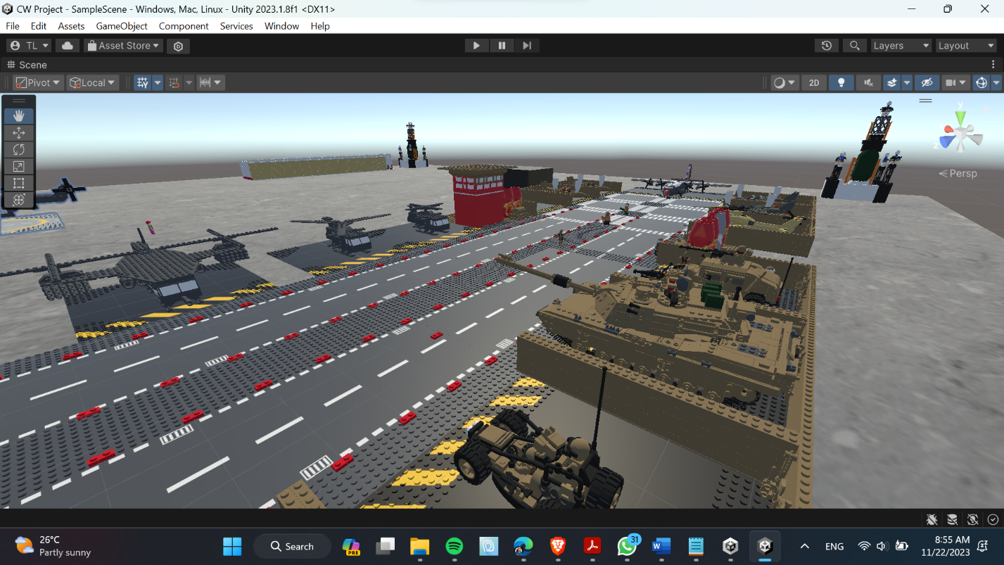

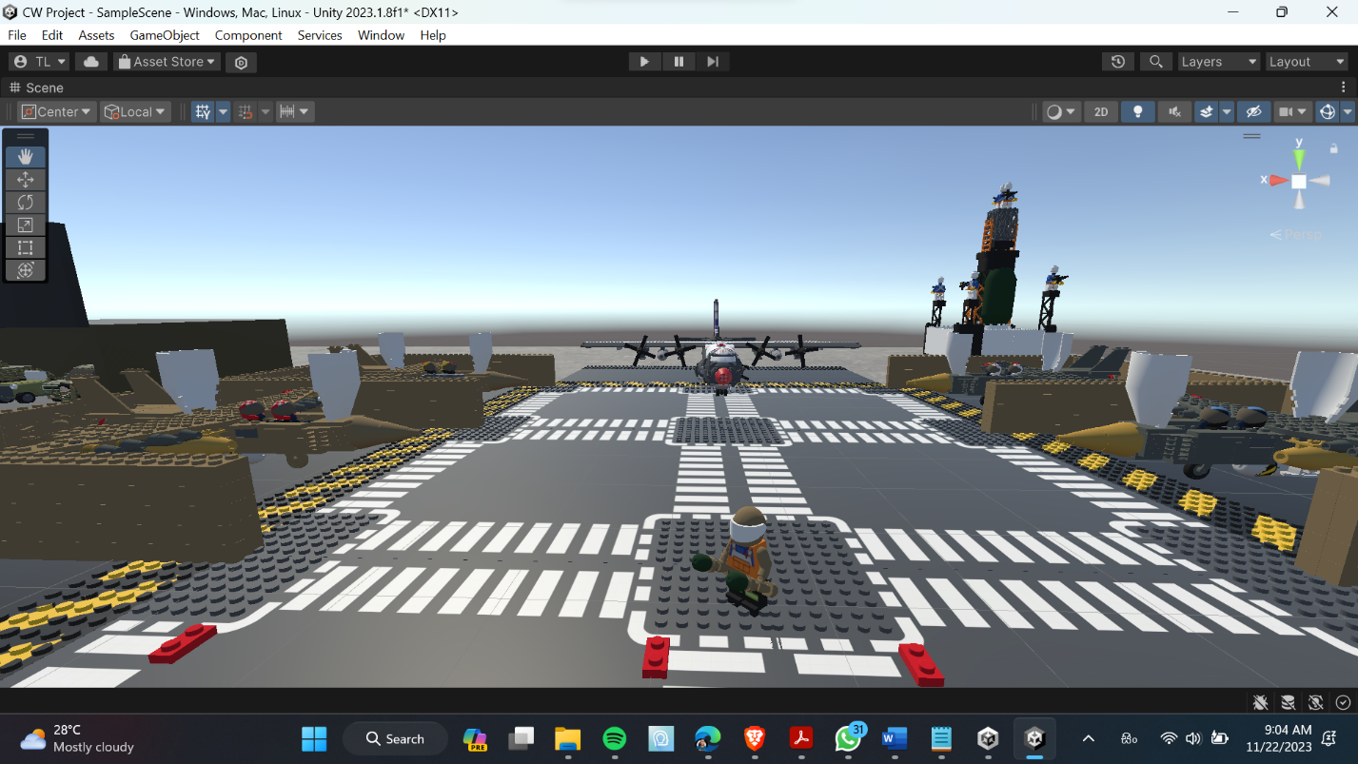

Military Base Headquarters

## 

Garage Area 1

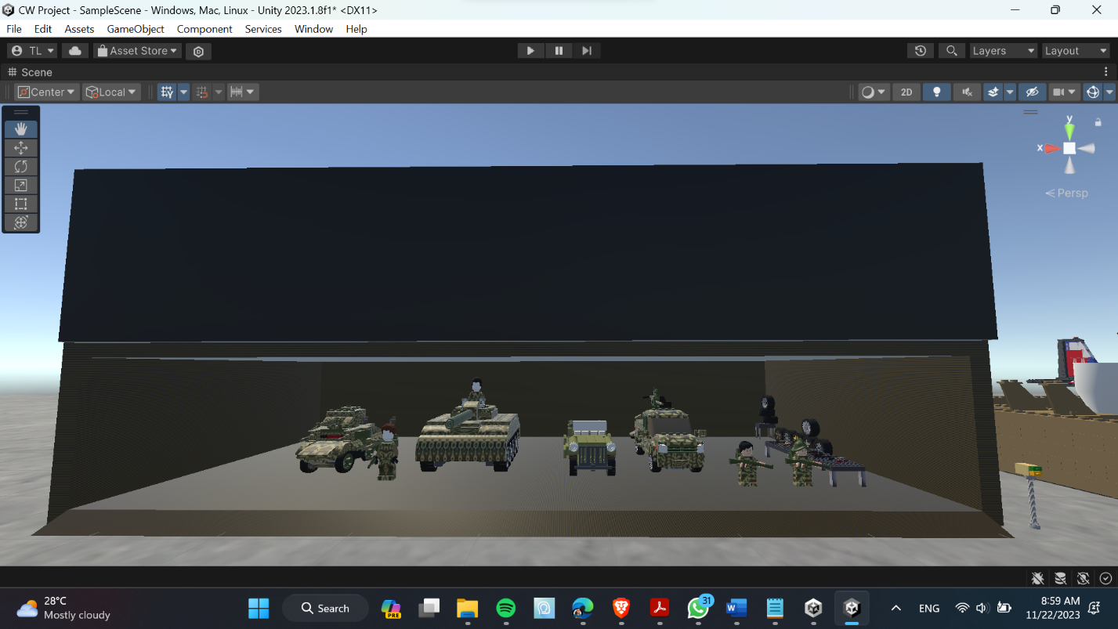

Garage Area 2

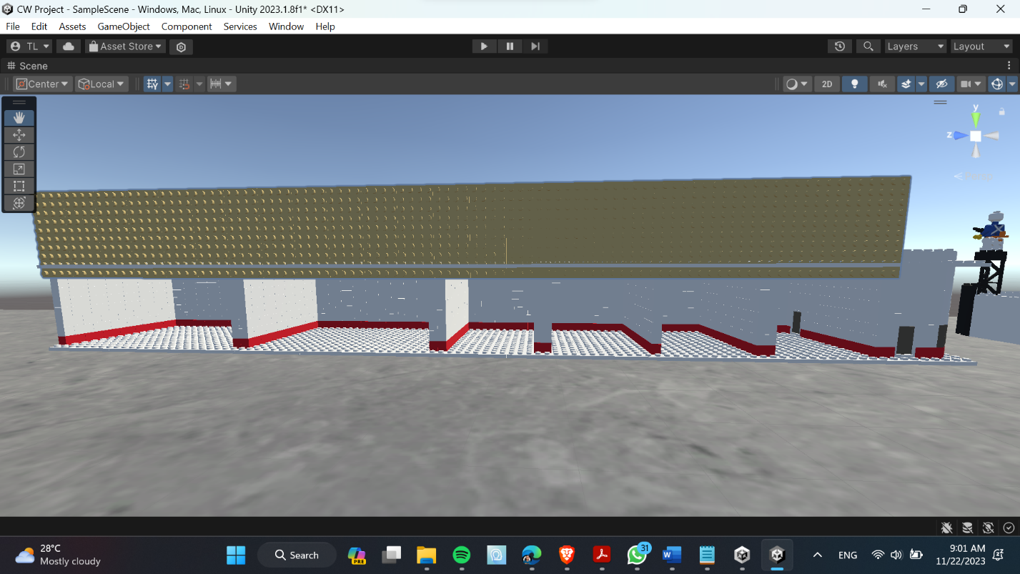

Rescue Area

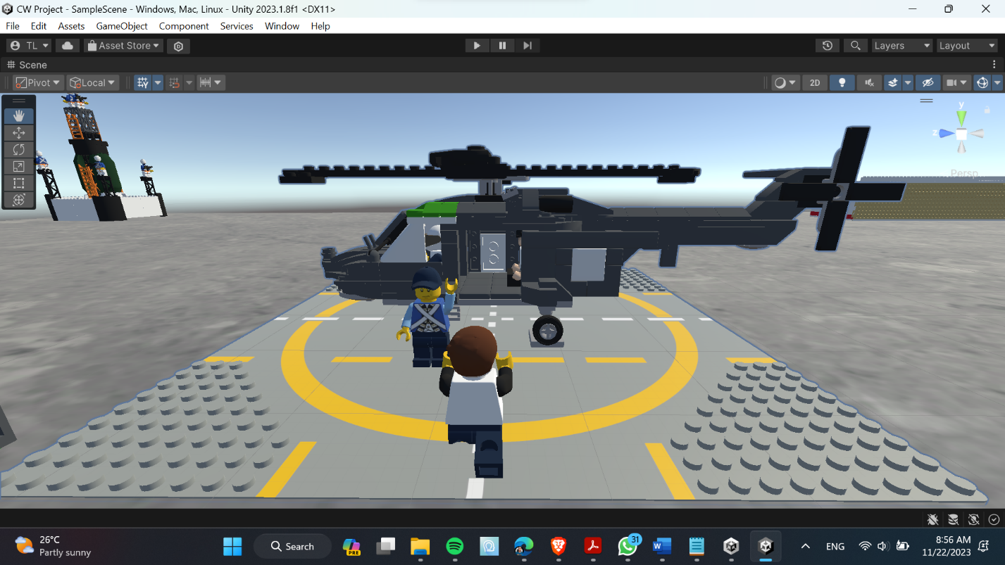

Watch Tower

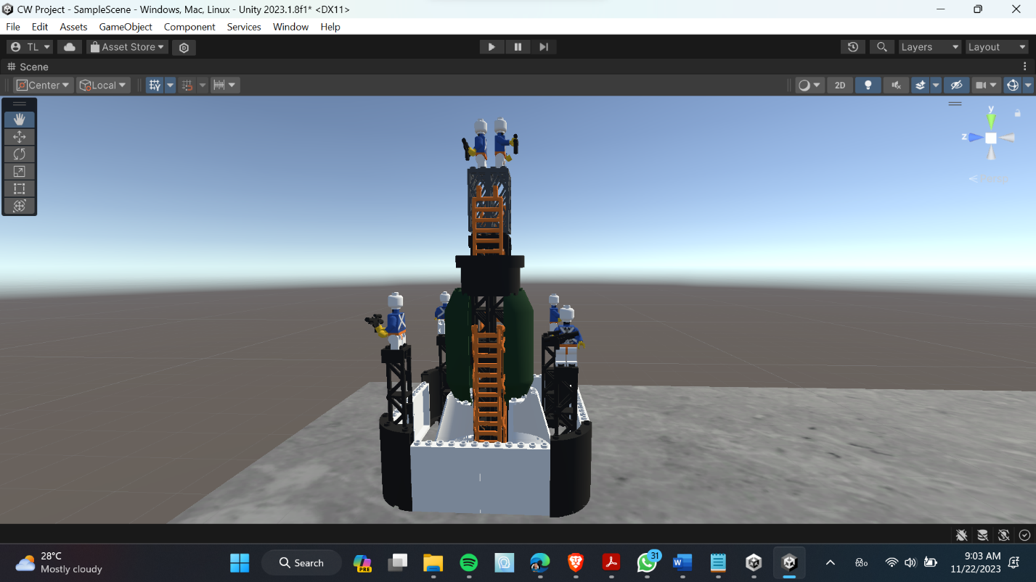

## **3DUI theory and concepts used (Based off lectures or book)**

Our 3D interactive military base simulation features an easy-to-use interface that was developed using the principles of 3DUI (Three-Dimensional User Interface). This interface allows users to travel to the base, interact with objects, and operate the simulation with easily.

1. Navigation

In this simulation, navigation, which includes both travel and wayfinding is quite important. Users can drive vehicles like army tanks, jeeps, and hummers or use more conventional means of transportation like walking around the facility. Giving users specific visual cues and landmarks makes it easier for them to navigate wayfinding, as it helps them comprehend where they are right now, identify where they're going, and choose the best route to get there (LaViola Jr. et al., 2017).

1. Selection

In a 3D environment, selecting objects can be done by using layering, occlusion, and depth cueing techniques. Weapons and vehicles in the foreground are shown clearly, and background objects are suitably obscured to allow users to quickly recognize and pick the needed objects. Using raycasting, users can choose from a variety of weapons at the firing range, including pistols, rifles, and shotguns. By pointing and clicking on the desired weapon, they are able to start interacting. In the same way, users can point and click on different vehicles in the garage, including army tanks, jeeps, and hummers (LaViola Jr. et al., 2017).

1. Manipulation

Using different 3DUI concepts makes it easier to manipulate objects, such as interfacing with car controls, controlling equipment, or manipulating interactive elements. Layering makes ensuring that interactive parts are reachable and react to user input, while raycasting enables users to point and click on objects to start interactions. Vehicle controlling is maneuvering and navigating the base by using the vehicle's controls, including the brakes, steering, and acceleration. To increase the realism of the simulation, gun controlling entails pointing and firing the chosen weapon while applying basic accurate and some realistic recoil and accuracy mechanics (LaViola Jr. et al., 2017).

1. System Control

Without conflicting with the immersive experience, system control elements including resuming, pausing, accessing menu options, and ending the simulation are smoothly integrated into the interface. The simulation can be controlled by users without obstructing their exploration and interactions according to these features, which are made to be simple to use and accessible. Users may easily manage the state of the simulation by accessing basic menu options such as start, play, pause, and exit (LaViola Jr. et al., 2017).

We have developed a user-friendly and captivating experience that enables users to easily navigate the military base, interact with objects in a natural way, control vehicles and weapons realistically, and effectively manage the simulation by implementing 3DUI principles into the interface design. This methodology guarantees that users can become fully immersed in the simulation and obtain a more profound comprehension of the military base environment.

# **Design Diagram**

## **Storyboard**

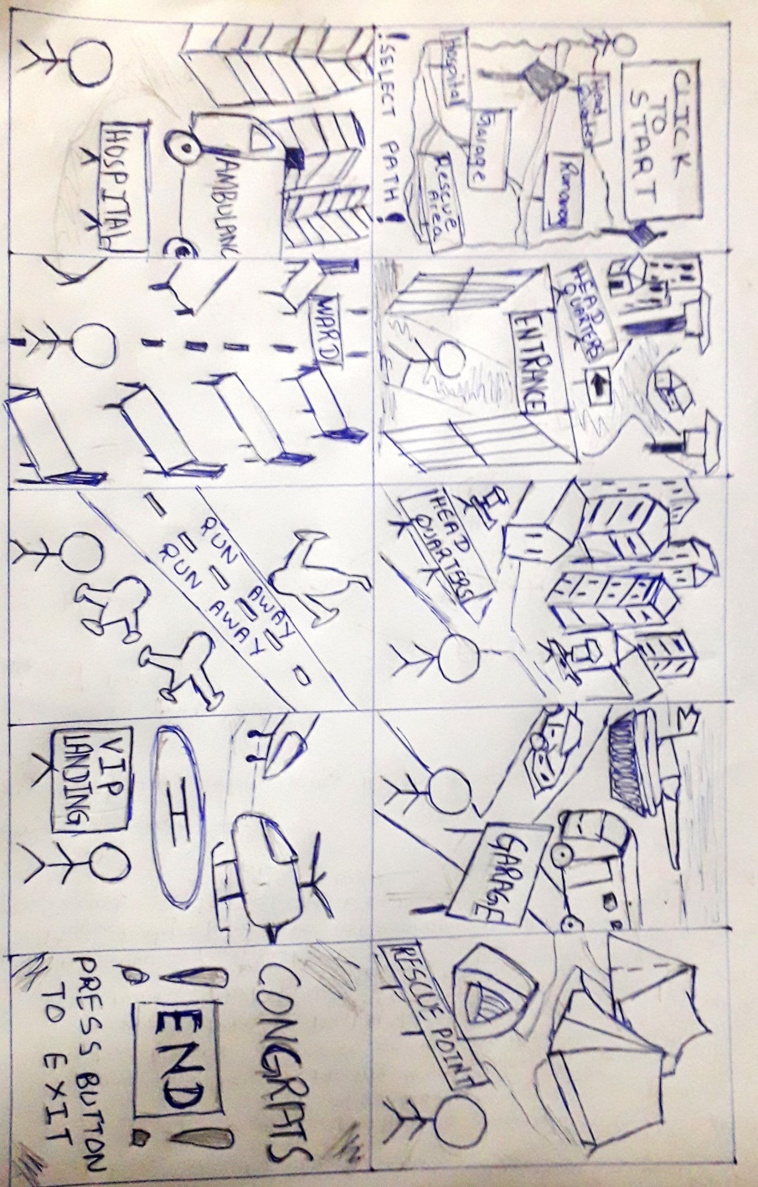

### Storyboard Flow

1. User gets to start off the game with a view of the map to the entire army base.
2. Once the game is started the user starts off near the entrance of the base where the character will be facing the camp.
3. The user could enter the headquarters, explore buildings and move around.
4. Next the user could enter the army garage explore a variety of vehicles and interact with them by opening their doors etc.
5. Next the user could enter the rescue point and explore the area by moving around.
6. The user could enter the hospital premises, move around interact with certain objects such as ambulances.
7. Next the user could enter the hospital premises and explore the interior such as wards.
8. The user could explore the run way and watch flights of various kinds take off.
9. Next the user could visit the VIP landing area where the user could experience helicopters take off and land.
10. Finally the user gets to exit the game with a button press.

## **Flow Chart**

Interact with Objects

Trigger animations on objects

No

Yes

Click “End” to Exit

Move character

Choose Path

Select Play

Load application

## **Use Case Diagram**ManMan

System

User

# **Project Management Methodology**

One of the key factors discussed before the start of our project was as to how we would plan and manage out our project on a strict timeline as per our requirements. Thus, we came to the agreement in using an **Agile** approach in designing our product.

The core reasons on our choice were that in following an agile approach we do have the luxury of changing existing components of our project at will, whereas approaches such as waterfall do not support this cause as changes can only be made once the final product is visible.

Furthermore, we did use the practice of Kanban, so that all members of the team had a clear visualizing flow of the project. This helped minimize conflicts among the group as the end milestone was clear to all members.  
Moreover, the practice of scrum was also followed as we had to meet certain deadlines, so a time boxed approach was vital for us as a group to ensure we met our desired deadlines. In the process of doing so sprints were held on regular basis, where all members showcase ideas in a limited time, this at the end of the sprint a certain goal was created which was to be reached on a certain timeframe.

# **Commercial Analysis**

3D scenes are vastly created across the globe for the general purpose of visualization of a particular scenario or simulation needs of a particular client. In contrast our project is more showcase type oriented, Where the user gets a majority of the interactions in a first-person point of view. A standout feature we do present to our user is the grand scope of objects to interact with alongside an extremely effective user interface which makes the final product commercially viable.

In the process of creating 3D environments a few commercial issues are common for many users. Some of these issues include compatibility issues as well as intellectual property issues. To prevent any such issues occurring within our project we have taken the measures of creating a majority of our own characters to be used in our scene alongside a few objects imported with the owner’s acceptance. Moreover, we wish to make our project compatible across multiple versions of software in future.

The usual theory of commercial analysis when creating a 3D environment is to focus on factors such as competitive landscape, Legal and regularity considerations, Technology structure and Strategic planning. We as a team have thoroughly researched on the above-mentioned factors and have made sure that our final product id fit for purpose.

# **Navigation Framework**

Our navigation framework will include nearly all mouse controls and keyboard functions to move around the base and inside certain buildings. As for now object selection is not implemented but in CW2 we plan to implement object selection and object manipulation. We plan on using multiple cameras as CCTV in our base so we can use a specific camera to look from. These cameras are preferably going to be controlled by mouse as it is much easier for the user to control rather than using a keyboard.

To do the specific task

To select the object

To look around

A

W

S

D

W A S D to move the character

The image above gives a brief idea on how navigation can be used alongside using the keyboard and look around from the mouse.

# **Interactivity**

The plane for interaction is to make the 2D UI to navigate form menu to the game, from menu to settings tab and back again by adding buttons to the UI and in the 3D game world to move around to certain areas to open doors, pick up objects, drive the vehicle. We plan on using the mouse to look around and to highlight what we want to select then we use the keyboard to use the object. For the keyboard we use to move around and interact with the objects to open and use the objects.

For state changes we plan on using more cameras ass CCTV in the base to look from a certain position in the base, we are going to make when a button is pressed on the keyboard the camera changes when we make our way in the headquarters in the base.

For collisions we have made everything with box colliders so that the player will not phase through the walls and vehicles. We plan on implementing more box colliders in coursework 2.

# **Animations**

We will aim to have animations for each model that the user can interact with. These animations will be triggered when the user clicks on the animations button or its keyboard counterpart if the animation can loop like our Lego minifigure walk cycle, then it will play continuously until stopped by the user. We also taught about adding animation to doors that can also be opened by clicks from the mouse or the keyboard (Unity Technologies, 2023).

We hope that it will give our Military base simulation a unique look. Some examples of animations are patrol Duty and recreation area. Like a soldier taking a break, perhaps sitting and reading a book in a designated recreational zone will give the simulation more uniqueness.

When the user assumes a command role, there will be interactive elements such as animated arms corresponding to mouse movements, providing a first-person perspective as if viewing the scene through the eyes of the base commander.

# **Shading, Lighting, and texturing**

Regards to the texturing utilized within our project the most appropriate textures were chosen based on camo designs. The pioneer reason behind this being that the core concept of our project being a simulated army base, therefore the textures below do fit for purpose.

A lot of attention was paid on the concept of lighting. After a thorough research we came to the conclusion of using a majority of matt surfaces on the objects present in our project. The reason behind choosing matt surfaces over gloss surfaces was due to the intense reflection coming off gloss surfaces which users find hard to deal with. Moreover, the options of Realtime Global Illumination was utilized to provide an optimized user experience. This assists in creating multiple light changes over a period of time as the project contains dynamic characters. Therefore, along with the movement of the character the perspectives of the arena change. Thus, the respective light intensities should change as well.

gloss

matt

The aspect of shaders was a vital component of out final component. The choice of vertex shaders was taken as our project contains a bulk of dynamic objects, Thus the control over dynamic lighting was found to be a lot easier. The bulk of shading is controlled with the aid of the Standard shaders in unity.

## **Shading:**

* Material Realism:

Ensure that the materials used in the simulation, such as the texture of the military base structures and equipment, are accurately represented in terms of color, reflectivity, and roughness.

* Uniformity:

Maintain a consistent shading style across all elements to create a cohesive and immersive environment. This includes soldiers, vehicles, buildings, and terrain.

## **Texturing:**

* High-Quality Textures:

Use high-resolution textures for military equipment, uniforms, and the environment. This enhances the level of detail and realism in the simulation.

* Camouflage Patterns:

Apply accurate camouflage patterns to military vehicles and uniforms. Pay attention to scale and color accuracy to maintain authenticity.

* Environmental Textures:

Texture the terrain with attention to detail. Incorporate textures for grass, dirt, and other elements to create a visually rich and varied landscape.

## **Special Effects**

* Explosions and Smoke:

Implement realistic particle effects for explosions and smoke. These effects should respond dynamically to environmental conditions and wind direction.

* Muzzle Flashes:

Add dynamic muzzle flashes and lighting effects when firearms are discharged. These should be synchronized with the firing animations of soldiers.

# **Discuss UI Efficacy**

The main concept of the UI (User Interface) of the application is to be as immersive as possible. The user interface will be divided into three sections, first user interface will be positioned at all the edges of the screen and enable a user with different varieties of interaction which are the user will rotate the ship to the x or y axis from its axis by pressing two separate buttons that might lead to an explicit direction of rotation. However, there are assorted conditions where using the interface is unnecessary which is when the user can just use the mouse for interaction that might cause convenience for the user due to using just one mouse and clicking on different objects or components to trigger an action such as animation. Likewise, as the user zooms in by using a button from the interface, the user might proceed with its interaction in the interior of the airship. Consequently, another interface will be permitted to the user where full control of cameras will be received. These cameras will be positioned at distinct varieties of angles. This user interface is accessible exclusively when the user zooms in inside the interior, nonetheless it will give the user lifelike immersion.

# **Group Contributions and Videos**

Work in progress video link: https://youtu.be/uKqoqI5TKA0

Peer review Video: https://youtu.be/h3Un0d6qA7s

Final Video per group:

Group contribution evidence:

